## Week 4 Homework Submission File: Linux Systems Administration

### Step 1: Ensure/Double Check Permissions on Sensitive Files

1. Permissions on `/etc/shadow` should allow only `root` read and write access.

- Command to inspect permissions: ls -l shadow from the /etc folder

- Command to set permissions (if needed): sudo chmod 600 shadow

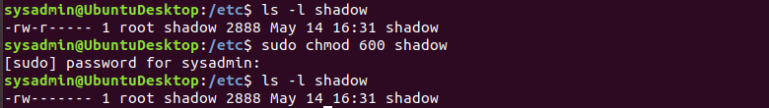

2. Permissions on `/etc/gshadow` should allow only `root` read and write access.

- Command to inspect permissions: ls -l gshadow from the etc folder

- Command to set permissions (if needed): sudo chmod 600 gshadow

3. Permissions on `/etc/group` should allow `root` read and write access, and allow everyone else read access only.

- Command to inspect permissions: ls -l group from the etc folder

- Command to set permissions (if needed): sudo chmod 644 group

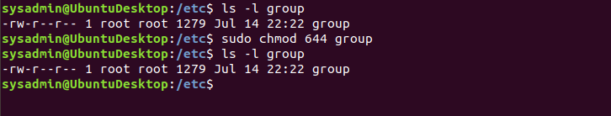

4. Permissions on `/etc/passwd` should allow `root` read and write access, and allow everyone else read access only.

- Command to inspect permissions: ls -l passwd done from the etc folder

- Command to set permissions (if needed): sudo chmod 644 passwd

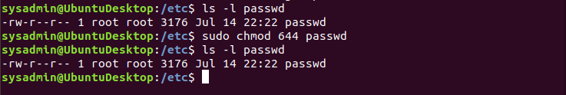

### Step 2: Create User Accounts

1. Add user accounts for `sam`, `joe`, `amy`, `sara`, and `admin`.

- Command to add each user account (include all five users):
sudo useradd sam
sudo useradd joe
sudo useradd amy
sudo useradd sara
sudo useradd admin
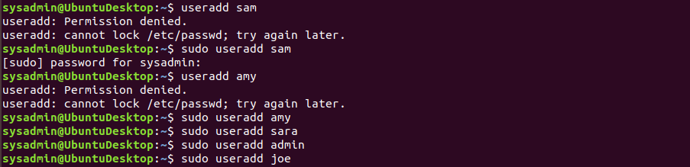

2. Ensure that only the `admin` has general sudo access.

- Command to add `admin` to the `sudo` group: sudo usermod -aG sudo admin
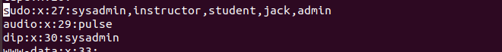

### Step 3: Create User Group and Collaborative Folder

1. Add an `engineers` group to the system.

- Command to add group: sudo addgroup engineers

2. Add users `sam`, `joe`, `amy`, and `sara` to the managed group.

- Command to add users to `engineers` group (include all four users):
sudo usermod -aG engineers sam
sudo usermod -aG engineers joe
sudo usermod -aG engineers amy
sudo usermod -aG engineers sara

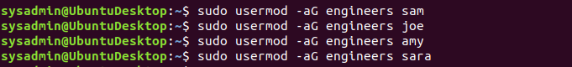

3. Create a shared folder for this group at `/home/engineers`.

- Command to create the shared folder: sudo mkdir /home/engineers

4. Change ownership on the new engineers' shared folder to the `engineers` group.

- Command to change ownership of engineer's shared folder to engineer group: sudo chgrp engineers engineer from the home file.
Sudo chown :engineers engineers

### Step 4: Lynis Auditing

1. Command to install Lynis: apt-get install lynis

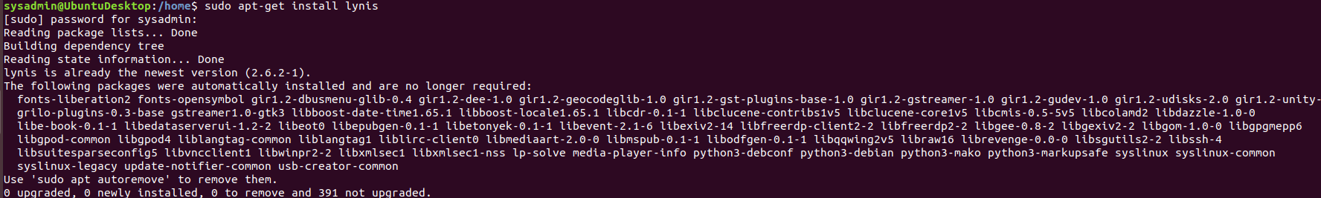

2. Command to see documentation and instructions: man lynis

3. Command to run an audit:

4. Provide a report from the Lynis output on what can be done to harden the system.

- Screenshot of report output:

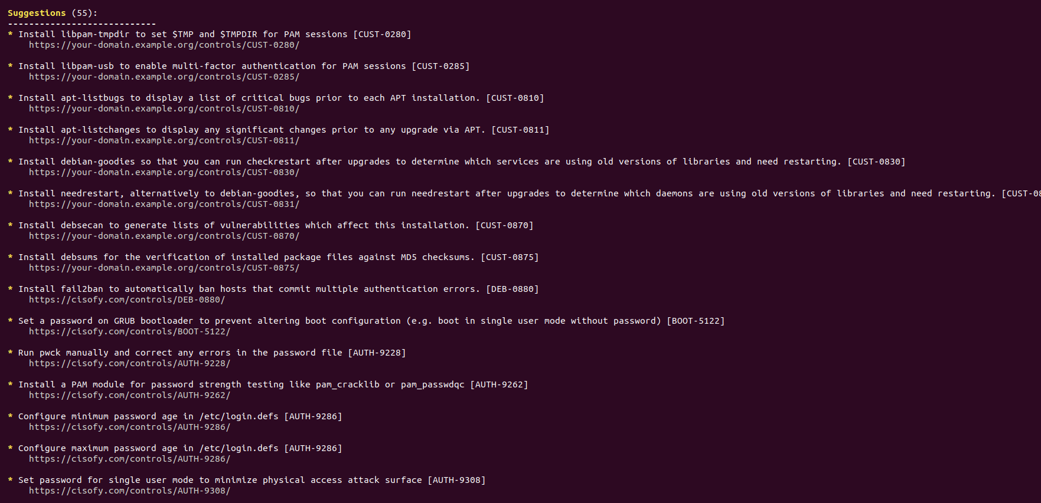
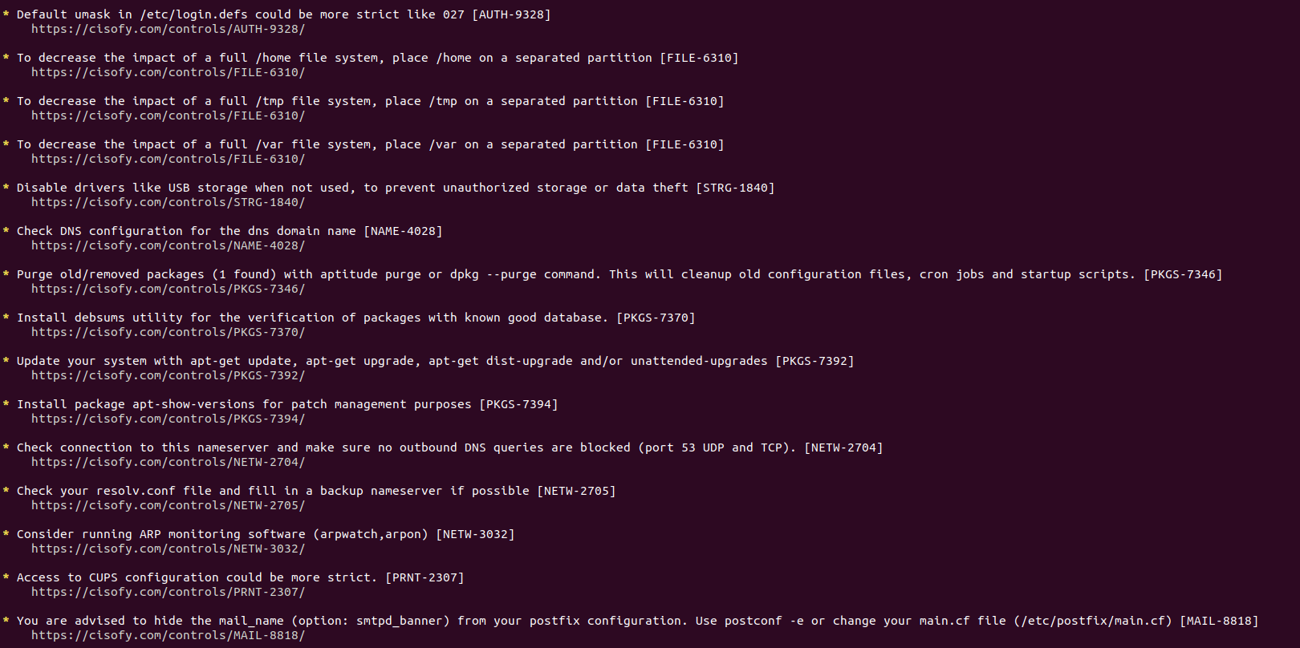
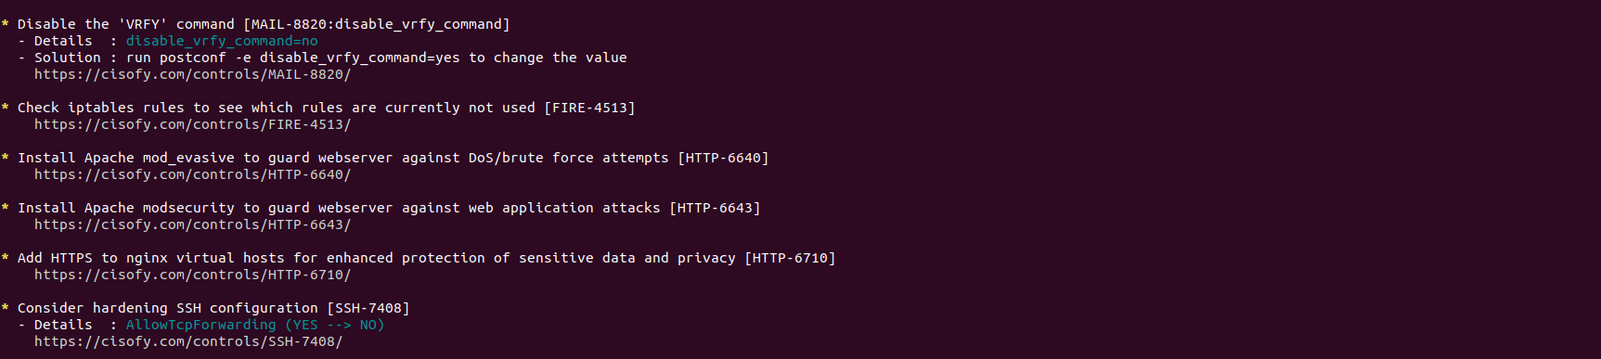
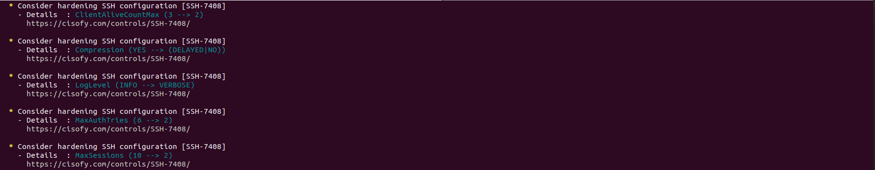
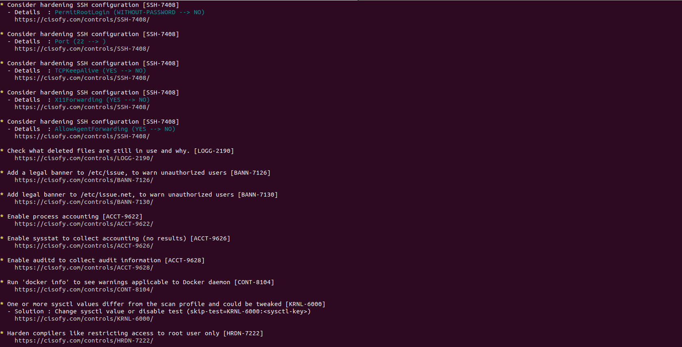

### Bonus
1. Command to install chkrootkit: sudo apt install chkrootkit

2. Command to see documentation and instructions: man chkrootkit

3. Command to run expert mode: sudo chkrootkit -x

4. Provide a report from the chrootkit output on what can be done to harden the system.
- Screenshot of end of sample output:
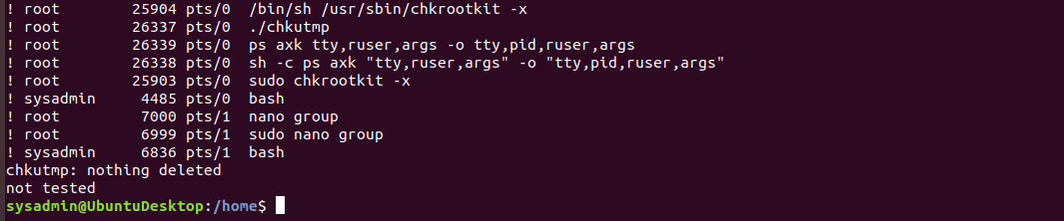

---
Â© 2020 Trilogy Education Services, a 2U, Inc. brand. All Rights Reserved.

